Requirement Analysis
Customer Journey Map, Solution Requirements, Data Flow Diagram & User Stories, Technology Stack
Date | 31 October 2026
Roll Number | 323103282099
Project Name | Incident Lifecycle Automation in ServiceNow
Maximum Marks | 4 Marks per section

Customer Journey Map
To understand what the solution actually has to support, I followed one caller, Michael Hoefer, through his whole experience of a VPN problem. Each stage shows what happens, where it happens, what usually goes wrong today, and how this project fixes it.
Stage | What happens | Touchpoint | Pain point today | How the solution helps
Report | Michael cannot connect to the Corporate VPN | Phone call to the Service Desk | Has to repeat the same details to several people | One incident record holds the whole story
Log and classify | The agent creates and classifies the incident | Service Operations Workspace | Category, service or CI often left empty | Category, subcategory, service, offering and CI are captured on the form
Diagnose | The agent looks for a known fix | Agent Assist | Fixes are buried in old tickets | Matching articles show up from the short description
Escalate | The incident moves to the Network team | Assignment group, Assign to me | Nobody is sure who owns it | The Network group and the Level 2 technician are named on the record
Change | A server restart needs approval | Emergency change request | Changes made without any record | Change is linked to the incident, which waits On Hold
Resolve | Fix applied and duplicate reports closed | Resolve action, child incidents | Duplicate tickets left open | Child incidents resolve with the parent
Learn | The fix is saved for next time | Create Knowledge | The same issue is solved from scratch again | A knowledge article is created from the incident

Solution Requirements

Functional Requirements
These are the functional requirements of the proposed solution.
FR No. | Functional Requirement (Epic) | Sub Requirement (Story / Sub-Task)
FR-1 | Incident creation | Create the incident in Service Operations Workspace with caller, short description, description and channel
FR-2 | Incident classification | Category, subcategory, impact and urgency (priority is calculated), service, service offering and configuration item
FR-3 | Knowledge integration | Search knowledge in Agent Assist, attach the article and mark it helpful
FR-4 | Assignment and escalation | Assignment group, "Assign to me", reassignment to Network, watch list and work notes list
FR-5 | Level 2 investigation | Level 2 picks up the incident, updates the CI and sets On Hold with reason "Awaiting Change"
FR-6 | Emergency change | Emergency change request with the affected CI, linked to the incident
FR-7 | Child incidents | Create a child incident from Related records; it resolves when the parent resolves
FR-8 | Resolution documentation | Probable cause, resolution code and resolution notes, then Resolve
FR-9 | Knowledge creation | Create Knowledge from the incident using the IT knowledge base and the Standard article layout
FR-10 | SLA tracking | Response and resolution SLAs that pause while the incident is on hold, shown in Task SLAs

Non-functional Requirements
These are the non-functional requirements of the proposed solution.
NFR No. | Non-Functional Requirement | Description
NFR-1 | Usability | Agents work from one workspace screen: form, activity stream, Agent Assist and SLA panel side by side
NFR-2 | Security | Role-based access (itil, admin) and knowledge base user criteria. I tested each step by impersonating the actual users
NFR-3 | Reliability | Every change is written to the Activity stream, and parent and child incidents stay in sync
NFR-4 | Performance | Only out-of-the-box forms and actions are used, so no custom script slows the form down
NFR-5 | Availability | Runs on the ServiceNow cloud and can be reached from any browser
NFR-6 | Scalability | New services, offerings, groups and SLAs are added as configuration, without writing code

Data Flow Diagram & User Stories

Data Flow Diagram
The diagram shows how the incident data moves. It enters with the caller's report, gets richer at every step on the same record, and finally leaves the process as a new knowledge article.
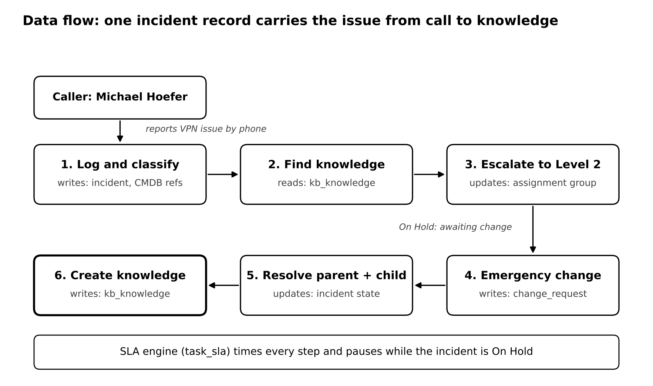
Figure 1: Data flow of the incident lifecycle

User Stories
User Type | Functional Requirement (Epic) | Story No. | User Story / Task | Acceptance Criteria | Priority | Release
Administrator | Setup | USN-1 | As an admin, I can create users and groups with the itil role | Users appear in their assignment groups | High | Sprint-1
Administrator | Service hierarchy | USN-4 | As an admin, I can create the Remote Access service and the Corporate VPN offering | Corporate VPN shows Parent = Remote Access | High | Sprint-1
Service Desk agent | Incident creation | USN-6 | As an agent, I can log an incident in Service Operations Workspace | Incident number is generated and caller and description are saved | High | Sprint-2
Service Desk agent | Classification | USN-7 | As an agent, I can classify the incident with category, service, offering and CI | All fields saved and priority calculated | High | Sprint-2
Service Desk agent | Knowledge | USN-8 | As an agent, I can attach a knowledge article and mark it helpful | Article shows Attached and Helpful, link visible in Activity | High | Sprint-2
Service Desk agent | Collaboration | USN-9 | As an agent, I can add people to the watch list and work notes list | Both lists saved on the incident | Medium | Sprint-2
Level 2 technician | Investigation | USN-10 | As a Level 2 technician, I can assign the incident to myself | Assigned to shows the technician | High | Sprint-3
Level 2 technician | Change | USN-12 | As a Level 2 technician, I can link an emergency change to the incident | Incident listed on the change | High | Sprint-3
Level 2 technician | Child incidents | USN-13 | As a Level 2 technician, I can log a repeat report as a child incident | Child listed under the parent | Medium | Sprint-3
Level 2 technician | Resolution | USN-14 | As a Level 2 technician, I can record the cause and resolution and resolve | Parent and child both show Resolved | High | Sprint-4
Level 2 technician | Knowledge creation | USN-15 | As a Level 2 technician, I can create an article from the incident | Article listed under Created Knowledge | High | Sprint-4
IT manager | SLA | USN-16 | As a manager, I can see SLA progress on the incident | Task SLAs show stage and breach status | Medium | Sprint-4

Technology Stack

Technical Architecture
Everything in this project runs on a ServiceNow Personal Developer Instance. Nothing is installed locally; the three types of users work through the browser, and five platform modules sit behind the incident record.
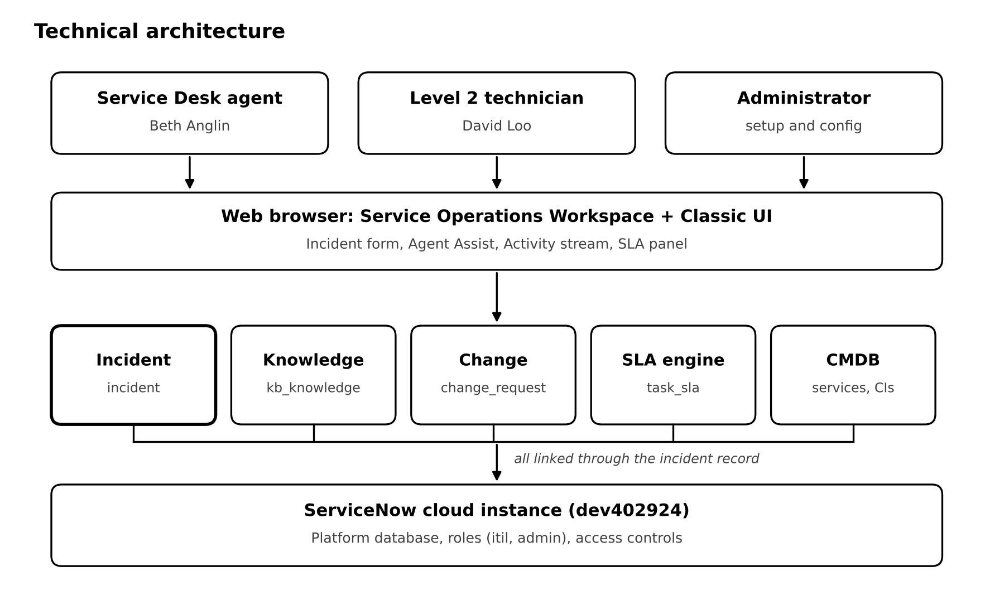
Figure 2: Technical architecture

Table-1: Components & Technologies
S.No | Component | Description | Technology
1 | User Interface | How agents and technicians work on incidents, changes and knowledge | Service Operations Workspace (Next Experience) and Classic UI
2 | Application Logic-1 | Incident lifecycle: states, assignment, parent and child sync, resolution | ServiceNow Incident Management
3 | Application Logic-2 | Article search, attach, helpful rating, create from incident, publish flow | Knowledge Management and Agent Assist
4 | Application Logic-3 | Emergency change linked to the incident | Change Management
5 | Application Logic-4 | Response and resolution timers with pause and breach | Service Level Management
6 | Configuration Data | Service hierarchy and the affected server | CMDB: Business Service, Service Offering, Server CI
7 | Database | All records live in platform tables (incident, kb_knowledge, change_request, task_sla, cmdb_ci_service, service_offering) | ServiceNow platform database
8 | Infrastructure (Server / Cloud) | Hosted instance, no local installation needed | ServiceNow cloud (Personal Developer Instance dev402924)

Table-2: Application Characteristics
S.No | Characteristics | Description | Technology
1 | Open-Source Frameworks | None used. The whole build is configuration on the platform | Not applicable
2 | Security Implementations | Role-based access, access controls, knowledge user criteria, impersonation testing | ServiceNow roles (itil, admin) and ACLs
3 | Scalable Architecture | Services, groups and SLA definitions are configuration records that can grow without code | ServiceNow multi-instance cloud
4 | Availability | The platform is hosted and maintained by ServiceNow | ServiceNow cloud data centres
5 | Performance | Out-of-the-box UI actions and lists, no custom scripts | Now Platform

